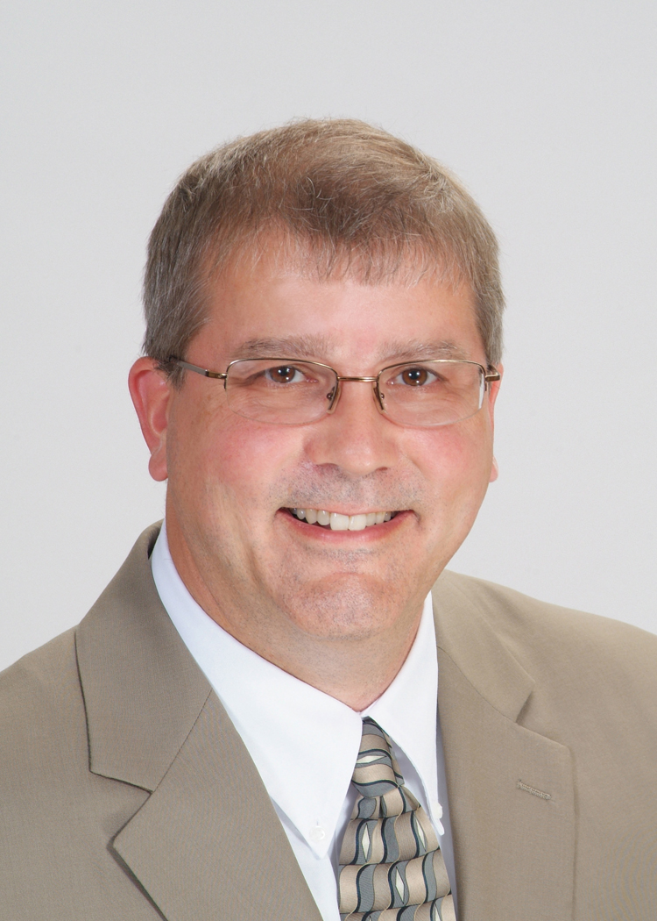  Office Location  151 Windy Hill Ln.,  Winchester, VA 22602 | Evan A. Wyatt, AICP | Director of Land Planning  Email: ewyatt@greenwayeng.com  Title and Responsibilities:  Mr. Wyatt is the Director of Land Planning and oversees all aspects of land planning, development programming, and land use entitlement work for clients of the Company. He provides project management services for development applications and designs, as well as oversight to the design team and other project managers in the Company.  Professional Profile:  Mr. Evan Wyatt is a professional land planner and has worked in the field since 1989. He is experienced in urban, suburban, and rural land use planning and has served as project manager for large-scale rezoning, master development planning, and mapping projects for private and municipal clients. His experience includes a wide range of Comprehensive Policy Planning, Rezoning, Proffer Programs, Master Development Planning for commercial, industrial, and residential projects, site design and subdivision design planning, transportation and infrastructure planning, and Capital Improvements Program Planning in the northern Shenandoah Valley, with an emphasis on Frederick County, the Towns of Stephens City and Middletown and the City of Winchester, Virginia.  Education:  1995 – Master of Planning – University of Virginia|  1987 – Bachelor of Science: Geography Planning Concentration –  Radford University  Certifications:  1996 – American Institute of Certified Planners  2012 – Expert Witness Catlett Farm, LLC v. Fauquier County Board  Civil Action No. CL12000004  Affiliations:  1996-2014 – American Institute of Certified Planning  1989-2014 – American Planning Association (VA Chapter)  Experience:  2002-Present – Director of Land Planning, Greenway Engineering  2000-2002 – Director of Planning, County of Frederick, VA  1989-2002 – Professional Planner, County of Frederick, VA  Projects:  Snowden Bridge Residential Planned Community: Frederick County, Virginia  Project manager for comprehensive plan amendment, rezoning, proffer and development program, general land use and transportation plan design for an  800-acre residential planned community containing 2,650 residential units and 500,000 SF of commercial land use.  Willow Run Residential Planned Community: Frederick County, Virginia  Project manager for comprehensive plan amendment, rezoning, proffer and development program, general land use and transportation plan design for a  360-acre residential planned community containing 1,390 residential units and 375,000 SF of commercial land use. This project involved VDOT exception approval for neotraditional transportation network design.  Rutherford’s Crossing Commercial and Industrial Park: Frederick County, Virginia  Project manager for rezoning and master development plan approval of a 155-acre commercial and industrial park including FEMA Office Complex.  Russell 150 Mixed-Use Development: Frederick County, Virginia  Project manager for rezoning and master development plan approval for 150-acre mixed-use plan design containing 500,000 SF of general office, commercial, retail, and residential land use. This project involved the creation of a Community Development Authority for significant VDOT transportation network improvements.  Northeast Land Use Plan: Frederick County, Virginia  Served as lead staff member in the creation of a wide-area land use plan including future land use development, future transportation networks, improvements to existing transportation networks, and future trail systems.  South Frederick Land Use Plan: Frederick County, Virginia  Served as lead staff member in the creation of a wide-area land use plan including future land use development, future transportation networks, improvements to existing transportation networks, and future trail systems.  Citizen Member, Foresight Middletown Steering Committee: Middletown, Virginia (2004-2005)  Served as a citizen member responsible for the development of future land use and transportation plans and policies to guide development within annex areas of the Town of Middletown.  Technical Advisory Committee Member Representative, Metropolitan Planning Organization: Town of Stephens City, Virginia (2004-2007)  Responsible for development and implementation of the 2030 Comprehensive Transportation Plan serving the MPO designated boundaries for Frederick County, the Town of Stephens City, and the City of Winchester.  Citizen Member, Frederick County Comprehensive Plans and Programs: Frederick County, Virginia (2008-2014)  Responsible for development of large-area and small-area land use and transportation plans and policies for future development in Frederick County.  Citizen Member, Frederick County Business Climate Assessment Committee: Frederick County, Virginia (2012-2014)  Responsible for development of recommendations for economic development strategic planning; development impact model revisions, and creation of Economic Development Authority for future development in Frederick County.

