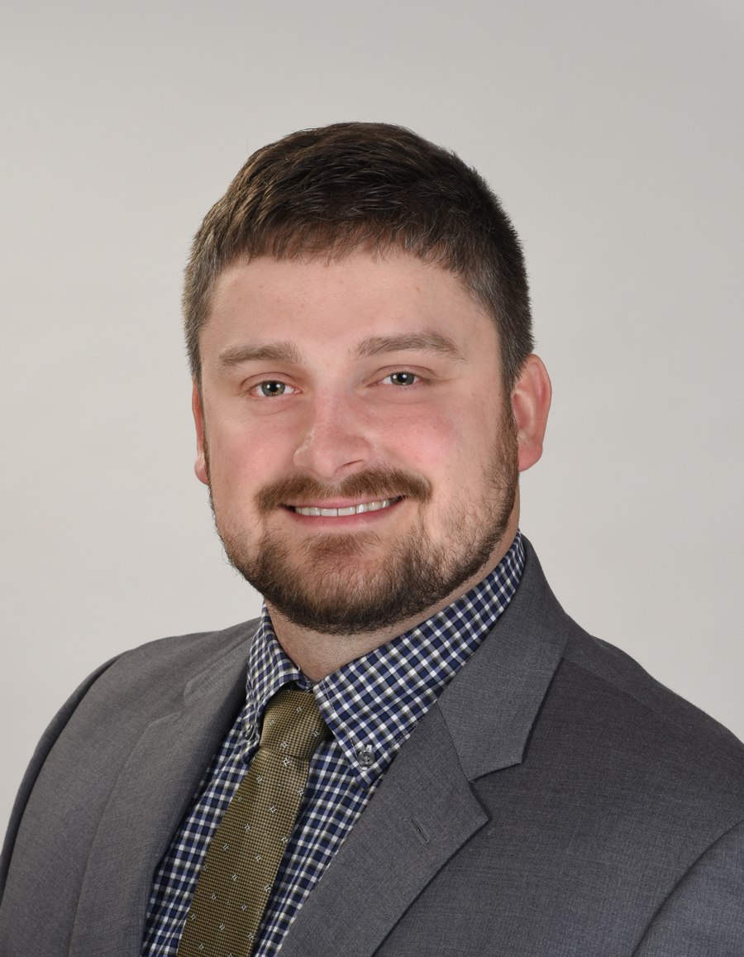  Office Location  704 Foxcroft Ave.,  Martinsburg, WV 25401 | Charles “Zack” Walburn, EIT | Project Manager  Email: cwalburn@greenwayeng.com  Professional Profile:  Mr. Walburn currently serves as Project Manager for the Martinsburg, WV office of Greenway Engineering. Mr. Walburn’s experience in both West Virginia and Virginia includes all aspects of engineering design, public representation, and management for residential, commercial, and industrial site plans. He has experience in stormwater management design, erosion and sediment control, water distribution system modeling, sanitary and storm sewer system design, and pump station design. Mr. Walburn also has experience in stream and wetland design including delineation, rapid bioassessment protocols, compensatory mitigation, natural stream design, and wetland restoration. Mr. Walburn is skilled in Bentley WaterCAD, AutoCAD Civil 3D, HydroCAD, Hydraflow, ArcGIS, and Carlson Civil Suite. At Greenway Engineering, Mr. Walburn is responsible for preparing and overseeing engineering civil/site designs and plans for jurisdictional approval and permitting. Mr. Walburn works closely with the design team to ensure that projects are completed on time using the most efficient and innovative approach available.  Education:  2012 – Masters of Science: Civil Engineering/Water Resources  – West Virginia University  2010 – Bachelor of Science: Civil and Environmental Engineering  – West Virginia University  Certifications:  2011 – West Virginia Engineer Intern, Certification #9460  Affiliations:  2013-Present – Trout Unlimited  2013-Present – Ducks Unlimited  Experience:  2018-Present – Project Manager, Greenway Engineering  2017-2018 – Project Engineer, Pennoni Associates, Inc.  2015-2017 – Senior Project Designer, Allegheny Surveys, Inc.  2014-2015 – Staff Engineer, Berkeley County Public Service Water District  2013-2013 – Restoration Specialist, AllStar Ecology, LLC  2011-2012 – Graduate Research Assistant, Civil and Environmental Engineering,  West Virginia University  Projects:  Project Title Here: City, State  Project Description Here.  Project Title Here: City, State  Project Description Here.  Project Title Here: City, State  Project Description Here.

