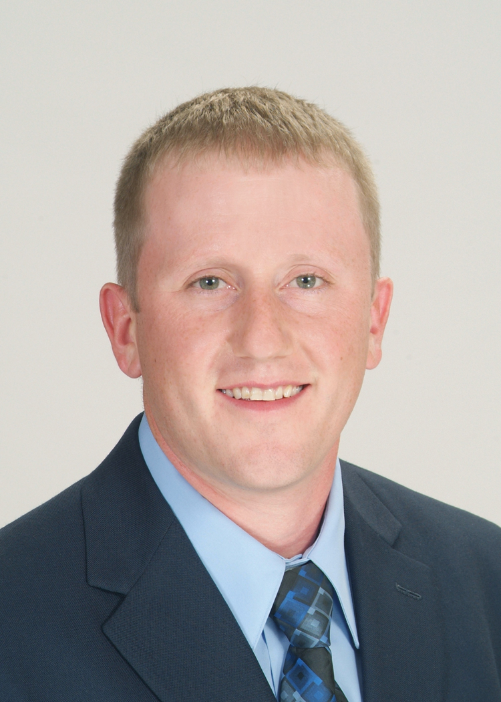  Office Location  151 Windy Hill Ln.,  Winchester, VA 22602 | Jeremy H. Ferguson, AOSS | Project Manager  Email: jferguson@greenwayeng.com  Title and Responsibilities:  Mr. Ferguson is the department head for the wastewater designs and operations sector of Greenway Engineering. His current responsibilities include, but are not limited to, managing projects from the onsite of customer contact to total construction completion, and future operations of commercial and residential wastewater treatment systems; Coordinate client’s budgets which may include personal or builder loans or various government grants; Solicit contractors and coordinate with clients for best price and solution; Prepare designs per construction, engineering, health and government regulations and compliance; Set project milestones, deadlines, contractors and any other resource requirements for project completion. These responsibilities may include coordination of meetings with the Virginia Department of Health (VDH) and Department of Environmental Quality (DEQ) for diverse complex projects requiring additional studies, licenses and approvals on both state and federal levels. His responsibilities also include the monitoring and inspection of all phases of the construction to ensure projects meet all design specifications and agencies’ regulations, from preliminary engineering meetings to final grade seed and straw; Obtain own elevations when required; Coordinate and resolve any issues encountered by client or contractor with necessary party; Ensure all resources and time coordinate with project deadlines and meet resource requirements.  Professional Profile:  Mr. Ferguson has been an environmental engineer since 2005.  - Established maintenance and monitoring program to alternative onsite sewer systems (AOSS) that discharge into soil absorbance drain fields due to new Virginia state regulations. Obtained Virginia State Alternative Onsite Sewage System Operator license through Department of Professional Regulations.  - This effort included development of all marketing, budget and projected revenue plans. Coordinated all customer and project demands as this market grew into wide geographic area expanding from the entire Lord Fairfax Health District.  - Established compliance sampling and field testing for alternative discharge septic systems and field testing per DEQ regulations including obtainment of Virginia State Class 4 Waste Water Operator license.  - Currently expanding the drinking water program for monitoring water and maintenance treatment plants to multiple classifications per ODW regulations including obtainment of Virginia State Class 4 Water Operator licenses.  Education:  2008 – Associate of Science: Civil Engineering – Lord Fairfax Community College  2008 – Associate of Science: Mechanical Engineering – Lord Fairfax  Community College  2008 – Associate of Science: Computer Aided Drafting – Lord Fairfax  Community College  Licenses:  2016 – Waterworks Operator Licensed Operator Class 4  2014 – Wastewater Works Licensed Operator Class 4  2011 – Alternative Onsite Sewage System Operator, AOSS, Department of  Professional and Occupational Regulations Commonwealth of Virginia  Certifications:  2009 – Basic Lab Skills for Wastewater Operations – Virginia Department of  Environmental Quality  2009 – Operation and Maintenance Service Provider Program – Virginia Onsite  Wastewater Recycling Association  2008 – Geoflow Operations and Maintenance  2007 – Puraflo Operations and Maintenance  Affiliations:  2007 – Virginia Onsite Wastewater Recycling Association  2007 – National Onsite Wastewater Recycling Association  Experience:  2005-Present – Environmental Engineer, Greenway Engineering  Projects:  Chimneys Hills Subdivision, Middletown, Virginia  Designed multiple single-family systems.  Rose Hill Estates, Purcellville, Virginia  Designed over 36 single family systems.  Loudoun County General Services, Virginia  Currently operate and maintain Franklin Park in Loudoun County which serves nearly 8,000 people total for both systems onsite.  Loudoun County General Services, Virginia  Operate and maintain Loudoun County Animal Shelter, which is a 3,000 GPD system.  Loudoun County General Services, Virginia  Operate and maintain Loudoun Heights Public Safety Center  Shen-Valley Market, Stephens City, Virginia  Designed, operate, and maintain commercial size wastewater treatment system.  Lord Fairfax Health District, Virginia  Design, operate, and maintain a combined number of over 2,500 single family systems.

